Synopsis of Proposal

THE EFFECT OF GARDENING ACTIVITIES ON
MOTOR SKILL DEVELOPMENT
OF PRE-K AND KINDERGARTEN STUDENTS

Melody R. Baker

- Sources of the potential subjects, derived materials or data:

The intent of this study is to evaluate whether participation in gardening activities affects childhood motor skills development. Classrooms in Harris County will be chosen based on their participation or non-participation in the Harris County AgriLife Extension Cylinder Gardening Project. There will be a minimum of 700 average pre-kindergarten and kindergarten aged students participating in the study.

The Beery Developmental Test of Visual-Motor Integration (VMI) is designed to assess preschool and early grade students, and will be used by the researchers to test the motor abilities of the control and treatment groups of children. The test takes between 10 and 15 minutes to administer and can be administered individually or as a group. It is considered to be culturally independent, and consists of a sequence of geometric figures, arranged from simple to complex, which are copied with pencil on paper. Each child will draw the figures one at a time to complete the test. The students copy the form in the space provided below each form. Scoring is determined based on the number of forms completed successfully where one point is given for each copied item for up to three consecutive failures. The Beery VMI will be administered and scored by the researchers.

Sample Questions:
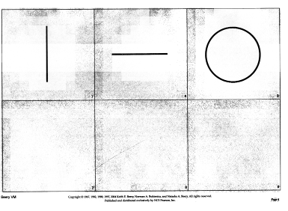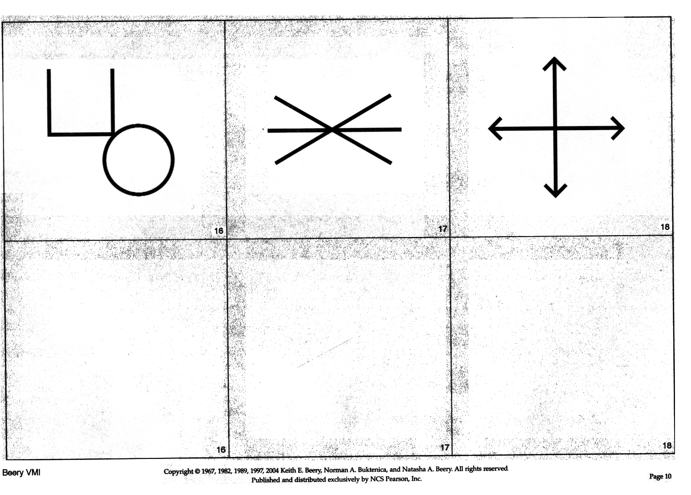
Beginning (easy) End (difficult)

A brief questionnaire will be sent home with each student in order to gain relevant information regarding their daily activities and the demographics of their family. This information will provide clues into what other factors may contribute to their motor development. Questions will be of a general nature, and will, of course, be kept confidential.

Sample questions are listed below:

What is your child’s age in years and months?
How many people live in your household?
How many children live in your household?
Does your child ride a bike/tricycle, play an instrument, play sports, garden, etc?
What are your child’s hobbies?

- Recruitment and Consent Procedures:

Based on information from Harris County AgriLife Extension depicting which schools and districts are participating in the Cylinder Gardening Project, a letter of intent (see attached) will be presented to potential schools/teachers within Harris County. Individual classrooms will then be selected based upon the response from these schools so that there are a minimum of 700 students in the study – with 350 students in the treatment group, and 350 students in the control group. Once selected, students in the study will be given a letter of consent describing the study and their role in it as well as a brief survey to take home for their parents to sign (see attached). Parents will receive a second copy of the consent form to keep for their records.

- Potential Risks:

There are no evident risks associated with this project.

- Eliminating and Minimizing Risk

The researchers will use a coding procedure to ensure the confidentiality of the students and parents participating in the study. No names will appear on either instrument. The coding procedure consists of two parts: The physical separation of identifying information and individual data by using coversheets, and the use of a code containing information required to group students by school, classroom, and treatment group. All information will remain locked in a filing cabinet at Texas State University and will be destroyed after five years

The researchers will provide coversheets on both the parent survey and the individual tests to code the information so that the demographic survey, and the students’ pretests and posttests may be matched. The coversheets will be removed once the instruments are coded. The code will consist of the students’ first and last initials (and possibly a number in the case that there are students with the same initials), a code number for the school they attend, a code number for their classroom, and a letter for their treatment group (Control or Treatment). Each part of the code will be separated by spaces.

Example of code number: AA 01 23 C

- Benefits

Participating classroom teachers will be given a $25.00 gift card to Wal-Mart to be used for gardening or classroom supplies. Each student will receive a Texas State University Bobcat pencil when they return their completed consent form and survey (They do not have to participate to receive the pencil. They only have to return the completed consent form.). The field of horticultural therapy will benefit from the study of motor-skills in relation to gardening activities, which has not been previously investigated.

- Risks vs. Benefit

In the risk to benefit analysis, the benefits of the school receiving the gift card and the students receiving the pencil outweigh risks because there are no foreseen risks involved to parents or students. Students will not be asked to change their normal routine. They will only be taking the Beery VMI which has been shown to be non-invasive and fun for students.

- Sites/Agencies Included in the Study

Elementary schools participating in the Cylinder Gardening Project will be selected from among schools in Houston ISD (schools have not yet accepted the invitation to participate). The Cylinder Gardening Project is a function of Harris County AgriLife Extension under the direction of Dr. Carol Brouwer. Dr. Brouwer is providing information on the schools participating in the program and serving as the link between the researchers and the schools in the study. Because all classrooms within a given school do not participate in the Cylinder Gardening project, the researchers will be able to select both control and treatment groups from within the same schools.

- Program/Field of study

Ms. Baker is currently studying under the guidance of Dr. Tina Marie Cade in the department of Agriculture. Her specific field of study is Agriculture Education. Ms. Baker hopes to one day teach children about nature and ecology in the context of school gardening.

- Approval and Committee

See Attached

- Has the project had prior review by another IRB? No

- Identify all individuals who will have access, during or after completion, to the unpublished results of this study.

Ms. Melody R. Baker – mb1082@txstate.edu
Dr. Tina Marie Cade – tc10@txstate.edu
Dr. Carol Brouwer – c-brouwer@tamu.edu
Dr. Deborah Stedman – ds43@txstate.edu
Dr. Brock Brown – brockbrown@txstate.edu
Dr. Doug Morrish – dm43@txstate.edu
Dr. Reed Richardson – cr36@txstate.edu

A copy of the completed thesis will remain on file in the Alkek Library on the Texas State University campus in San Marcos, TX.

